AstroSage Analysis
Tasks
Objective Questions:
1. What is the total no. of tables present in the data?
A) 1 table, Excel Dataset contains only one sheet with multiple rows and columns, so only 1 table present.
2. What is the total no. of attributes present in the data?
A) 35 attributes, counting all the column headers, there are 35 columns.
3. The data consists of some inconsistent and missing values so ensure that the data used for further analysis is cleaned.
Before beginning any analysis, I examined the dataset to identify structural issues, missing values, and inconsistencies that could affect accuracy. The goal was to standardize formats, validate key financial fields, and prepare a clean, reliable dataset for dashboard development.
- Data Understanding & Validation: Reviewed dataset structure to confirm purpose and relevance of each field.Checked for correct data formats, logical values, and consistency across records.
- Duration Standardization:Converted the Duration values into a proper time format to ensure accurate calculations in subsequent analyses.
- Earnings Validation:Verified the Amount and Net Amount columns to confirm they correctly reflected astrologers’ earnings.Identified anomalies and incorrect values that required correction.
- Recalculated values using:
  - Astrologer Earning = Amount × 40%
  - Net Income = Amount − Astrologer Earning
- Final Cleaning Outcome:Removed inconsistencies and corrected erroneous entries.Applied accurate formulas for earnings calculation.Ensured dataset integrity for further pivot table creation and dashboard analysis.

4. What is the change in daily call volume day by day and also find the average daily call volume.
- The pivot table shows the number of calls per day, using CallSid
- The day-over-day change in call volume is calculated in a separate column beside the daily count.
- Average Daily Call Volume: 246.03 calls/day
- (Calculated using =AVERAGE(B2:B35) on daily CallSid counts)
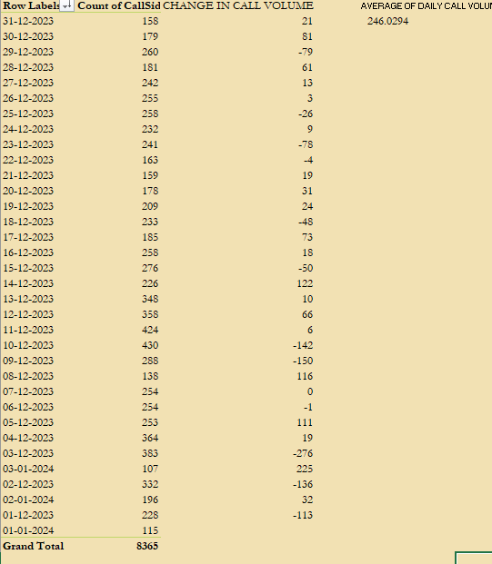

5. Which months experienced the highest and lowest call volumes?
- The highest call volume was in December, with 7947 calls.
- The lowest call volume was in January, with 418 calls.
- This was identified using a Pivot Table grouped by Months/year on the CallDate field.
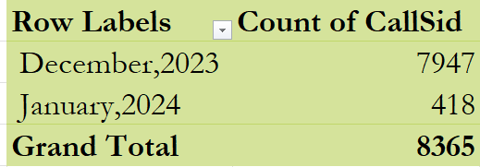
6. What is the total operational cost for that month?
- Added Sum of astrologersEarnings to the Values section to calculate the total earnings paid to astrologers.
- In the Filters section, selected all consultation types to include all call and chat-based consultations.
- The total astrologersEarnings was treated as the operational cost for each month.
- January: ₹5360
- December: ₹93786

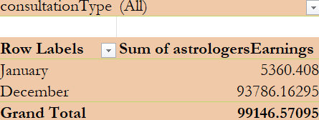

7. What is the average number of calls handled per agent per day?
A) Total Calls: 8365
- Unique Agents: 133
- Active Days: 34
- Average = 8365 ÷ (133 × 34) = 1.85 calls/day/agent

8.How many repeat callers are there, and what percentage of total calls do they represent?
- Total Callers : 3,629
- Total Calls (all calls made): 8,508
- Repeat Callers: 1,277 users
- Total Calls by Repeat Callers: 6,156 calls
Repeat Calls Calculation:
- Actual repeat calls = Total calls by repeat callers - First call for each repeat caller
- Repeat calls = 6,156 - 1,277 = 4,879 calls
Percentage Calculation:
- Percentage of total calls by repeat callers
= (4,879 ÷ 8,508) × 100
= 57.34%

9.What are the total sales generated by the call centre for each product category?
- Call: ₹168521 — the dominant revenue contributor.
- Chat: ₹45,495 — secondary source of revenue.
- Complementary: ₹0 — Free Call & Free Chat provided free of charge, no revenue generated.
- Public Live Call: ₹51 — negligible revenue contribution.
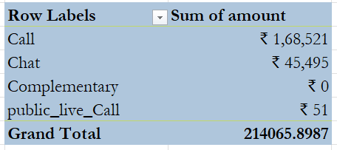
- Grand Total Sales: ₹214065

10.How many calls were made for each user ID and guru ID?
Created two separate Pivot Tables:
  - Pivot Table 1: User ID in Rows and Count of Calls in Values.
  - Pivot Table 2: Guru ID in Rows and Count of Calls in Values.
Applied a filter on Consultation Type to exclude “Chat” so only call-related data was analyzed.
- The User ID pivot table shows that certain users have made more than 100 calls, indicating strong engagement and loyalty towards the platform.
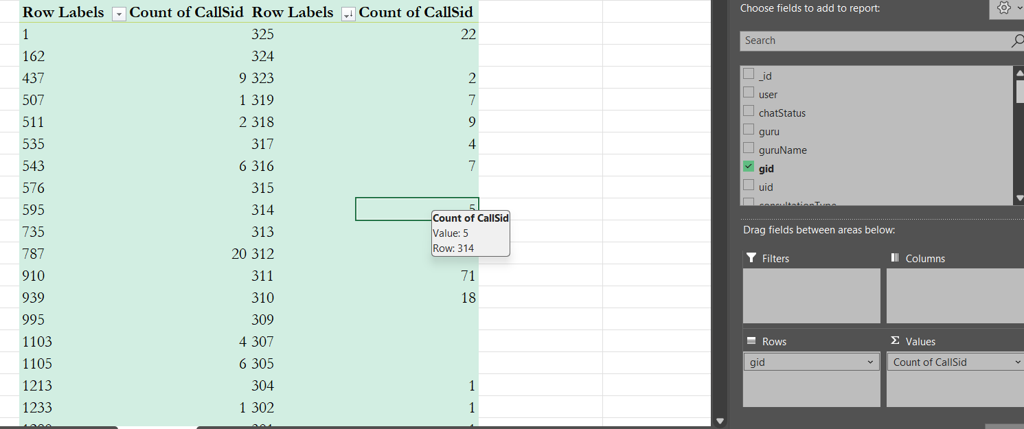
- The Guru ID pivot table reveals that some users prefer specific gurus, demonstrating personal rapport or perceived expertise.

11 .What is the correlation between call duration and customer satisfaction?

The correlation between call duration and customer satisfaction is 0.00756, indicating almost no relationship between the two.

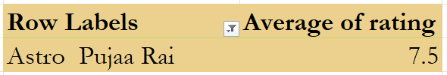
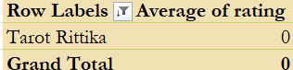
12.Which guru has the highest and lowest customer satisfaction scores?
- Highest Rating: Astro Pujaa Rai — 7.5
- Lowest Rating: Tarot Rittika — 0

13.What is the average customer satisfaction score by month?
- January: 2.68
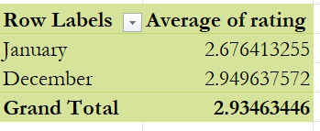
- December: 2.95

14. How many categorical columns are there in the data? [Search about categorical and continuous data, and try to answer this question]
The dataset contains 17 categorical & 8 continuous.
- Reviewed the dataset containing 40 columns in total.
- Identified categorical columns based on data types object (string/text) and bool (True/False values).
- Classified these fields as qualitative variables representing statuses, names, flags, or time-based labels rather than numeric measures.
Observation:
- Object-type categorical columns: _id, user, chatStatus, guru, guruName, gid, uid, consultationType, website, Type of User, refundStatus, createdAT, updatedAt, statementEntryId, chatStartTime, chatEndTime, timeDuration, Day, Month, Monthyear,Year, RechatStartTime, RechatEndTime, RetimeDuration, callChannel, callIvrType, callStatus, CallSid, astrologerCallStatus, region, userCallStatus, rating.
- Boolean-type categorical columns: isWhiteListUser, queue, freeCall, freeChat.
- These fields provide qualitative descriptors and binary indicators useful for segmentation, grouping, and non-numeric trend analysis.

Subjective Question:
- Should the investment be used to hire more agents, improve training programs, or upgrade call center technology?

- Approach:
- First, I calculated the average number of calls handled per agent per day, using the pivot table sheet I created earlier, which showed a result of 1.85 calls/day/agent.

- Then, I created a pivot table to check average customer satisfaction scores per guru. Out of almost 150 gurus, around 63 gurus had an average score below 3, which is alarming and shows a quality gap.

- I also analyzed the call status distribution using another pivot where both Rows and Values are based on callStatus. This showed that out of 28,027 total calls, only 22,939 were completed, while the remaining 5,088 (almost 18%) failed, were incomplete, or not answered.

- Work:
- Agent Load Analysis: I calculated average calls per agent per day from my pivot tables: Total Calls ÷ (Total Unique Agents × Active Days) = 8365 ÷ (133 × 34) = 1.85.
Screenshot 1:
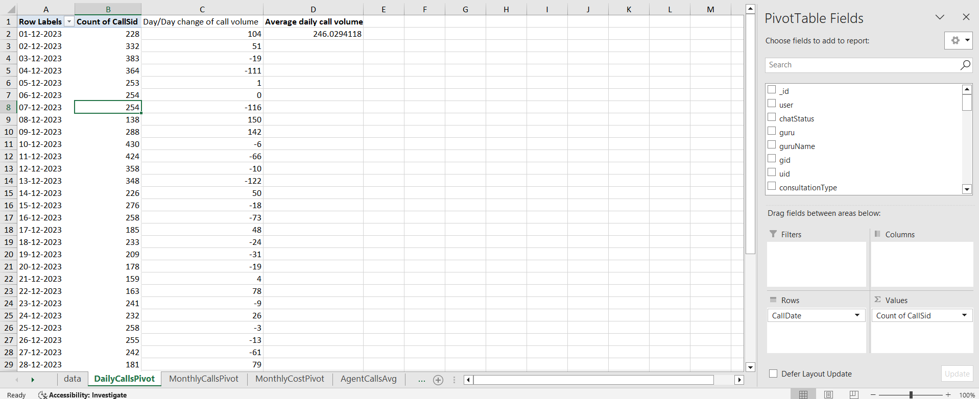

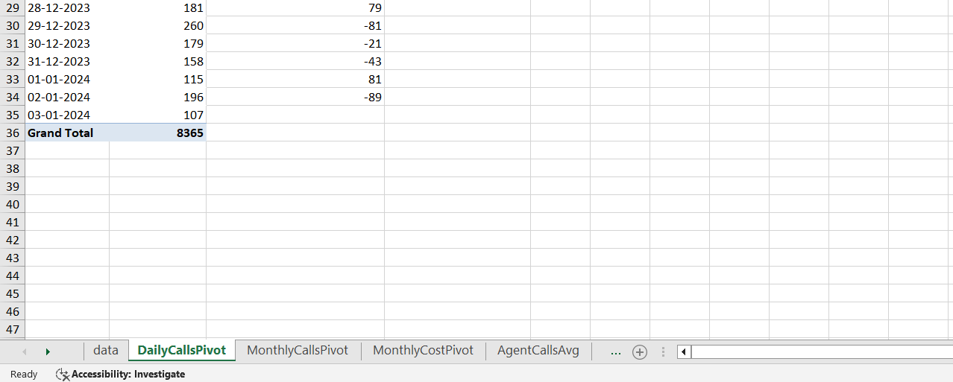

- Guru Rating Insights: I created a pivot table using guruName in rows and Average of Rating in values. Then I applied filters/sorting to count how many gurus were performing below expectations (average rating < 3). Result: around 63 out of 150.
Screenshot 2:
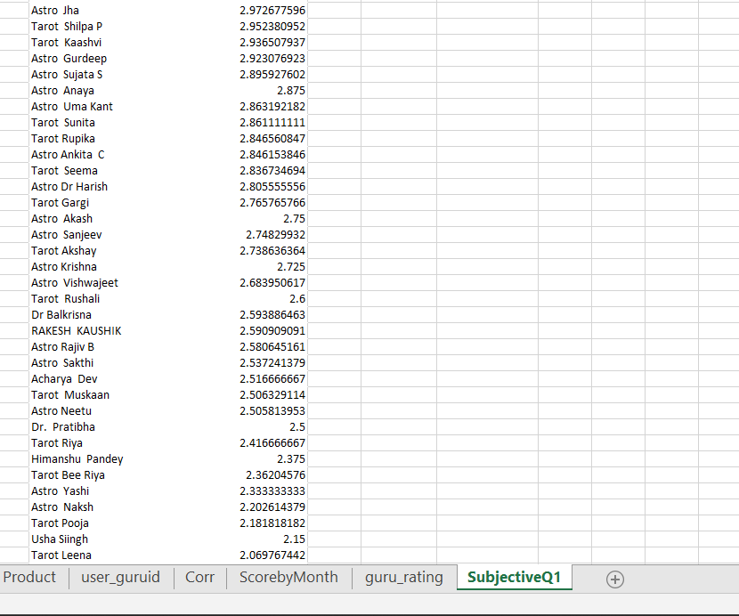

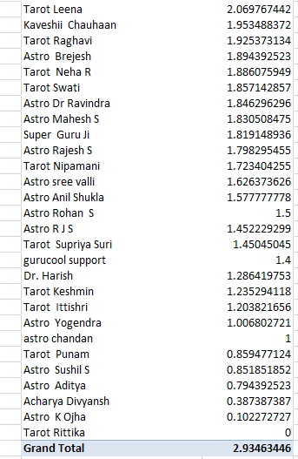

- Call Status Breakdown: I used callStatus in both row and value areas in a pivot. That helped me see that 18% of calls did not complete, which may be caused by tech issues or inefficient call handling.
Screenshot 3:

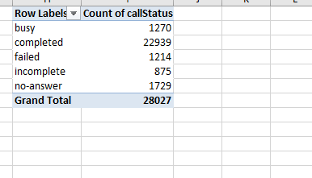
- Insights:
- From the calculations I performed, I found that each agent is handling just 1.85 calls per day. That’s quite low considering the overall workload. This clearly tells me that we have enough manpower already and they’re not fully occupied throughout the day. So, if we think about hiring more agents right now, it might actually lead to increased idle time and won’t bring any meaningful improvement.

- While analysing the ratings using a Pivot Table, I filtered out all gurus with average scores below 3 (on a scale of 5), and I found that 63 out of 150 gurus are in that category. That’s over 40%. This raised a red flag for me because it directly reflects on the quality of service that users are experiencing. It shows there might be a gap in communication or domain expertise, and this is likely affecting user satisfaction and long-term retention.

- I also did a count of all call statuses using a Pivot Table (rows = callStatus, values = callStatus), and noticed that out of 28,000 total call attempts, around 5,000 calls ended up as incomplete, failed, or no-answer. That’s roughly 18% of total call volume. So that’s a huge loss both in terms of business opportunity and customer trust. These failed connections could be due to poor infrastructure, technical issues, or even agents not being ready to take calls.

- Recommendation:
- Since a large number of gurus have low average ratings, my first recommendation would be to invest in structured training sessions. Especially focused on communication skills, customer empathy, and flow of the consultation. With better training, guru performance can be improved significantly, and that would directly reflect in higher satisfaction ratings, better feedback, and possibly even higher conversions.

- Looking at the high failure rate of calls, I strongly believe that part of the investment should be used to upgrade our technical setup — whether it’s server stability, call routing or mobile app functionality. This will help reduce call drop rates and ensure more smooth customer interactions.

- At this point, hiring more agents is not something I Would recommend. Since every agent is already handling fewer than 2 calls/day, adding more staff will only increase operational cost without any real benefit. The current team can handle more. We just need to optimize their performance and support them better.

- What are the potential risks of each investment option (hiring, training, technology upgrades), and how can they be mitigated?
- Approach:
- To answer this question thoroughly, I divided it into three categories: hiring, training, and technology upgrades. I used Excel to look at key operational metrics like average calls handled per agent per day, guru ratings, and call statuses. I also made pivot tables and charts to accompany each investment analysis.

- These visual insights enabled me to critically evaluate the current system's performance and guide my recommendations based on actual metrics rather than assumptions.

Work:

- Chart 1: Average Calls per Agent per Day – A bar chart indicating that each agent handles only 1.85 calls per day helping me in determining hiring needs.
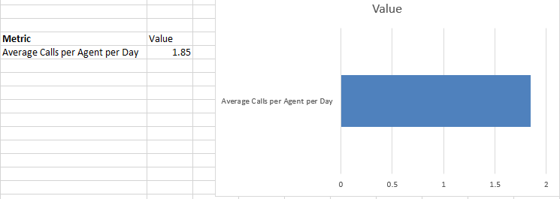

Chart 2: Guru Ratings Distribution – A sorted bar chart of all guru average ratings revealed that 63 out of 150 gurus (or roughly 42%) have ratings below 3.
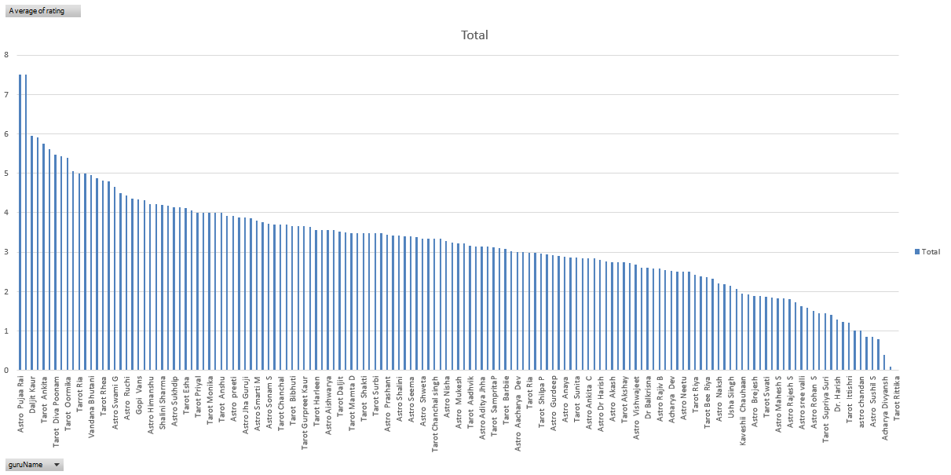
Chart 3: Call Status Breakdown – A pie chart reveals that approximately 18% of total calls were incomplete, failed, busy, or had no response status, indicating system or training gaps.
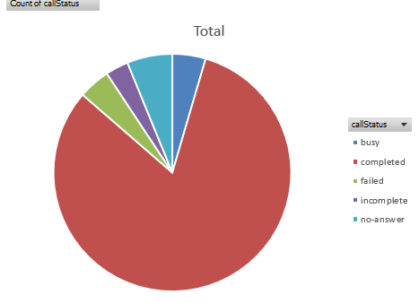
- Potential Risks and Mitigation:
Hiring More Agents
Risk:
There's already underutilization - each agent handles just 1.85 calls/day. Hiring more agents might lead to increased idle time, wasted salaries, and lower productivity.

Mitigation:
Before hiring, I’d suggest implementing a utilization tracker dashboard to monitor workload patterns. Only if consistent peak load appears, then consider hiring on-demand or even part-time agents.
Training Program
Risk:
If the training content isn’t aligned with real focus points like soft skills or tech tools etc.., it may not improve customer satisfaction scores. It could be a wasted expense if done without analysing agent needs.

Mitigation:
I’d first analyze low-rated guru trends using PivotTables and filters - identify the common areas where ratings drop. Then, create tailored training modules targeting those exact gaps like empathy, voice tone etc... Post-training, remeasure average ratings.

Technology Upgrades
Risk:
Tech upgrades can be costly and disrupt live operations. Also, investing in wrong tools just like fancy dashboards that no one uses leads to ROI loss and team frustration.

Mitigation:
I’d suggest starting with incremental improvements — upgrading queue management or call routing based on actual failure reasons as visible in callStatus breakdown: failed, no-answer, incomplete. Use Pie Charts and Countif/Filters to prioritize where the system struggles. So, roll out sequential upgrades to check the performance.

- Chart/Excel Tools Used:

- Pivot Tables to group and summarize values: call counts, guru ratings, call status etc..

- AVERAGE () Formula for average calls per agent.

- Pie Chart for call status analysis.

- Bar Charts for rating distribution and performance overview.

- How does AstroSage's call center performance compare to AstroGuru's average call volume, customer satisfaction, and agent performance? Will you use any aggregation function or a visualization here to solve the problem?
A) To answer this question completely, I divided it into two parts:
Approach:
Since no dataset was available for AstroGuru, I made a fair and logical comparison using public reviews and ratings from verified sources. For AstroSage, everything is backed by actual Excel work

- AstroSage - To evaluate, I created Pivot Tables and Charts in Excel using the provided dataset:
- Average daily call volume
- Agent performance (calls handled per day)
- Average customer ratings

- AstroGuru - Because no dataset is provided for AstroGuru, I explored external sources such as:
- Google Play Store Reviews for AstroGuru
- Trustpilot Reviews for AstroGuru
- Also Read some on Reddit, Quora.
II. Work
Excel Work (AstroSage): All this was done in the ‘SubjectiveQ3’ Excel sheet
I used PivotTables and charts to derive insights:
- Training Program
- Total calls: 8365
- Active days: 34
- Average = 8365 / 34 = almost 246 calls/day
- Created using: PivotTable: Rows = CallDate, Values = Count of CallSid
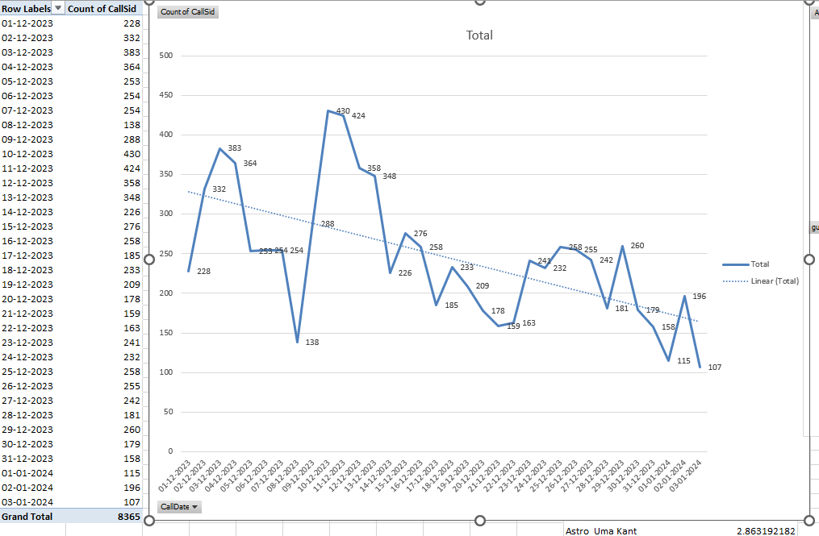
- Agent Performance
- Unique agents: 133
- Average = 8365 / (133× 34) = almost 1.85 calls/agent/day
- I Got this value from Agent list pivot
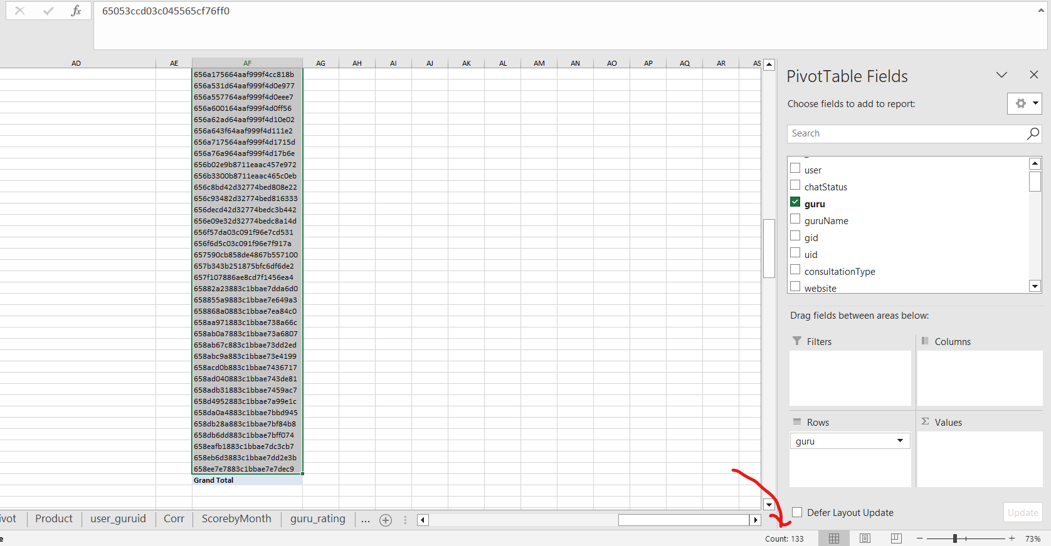
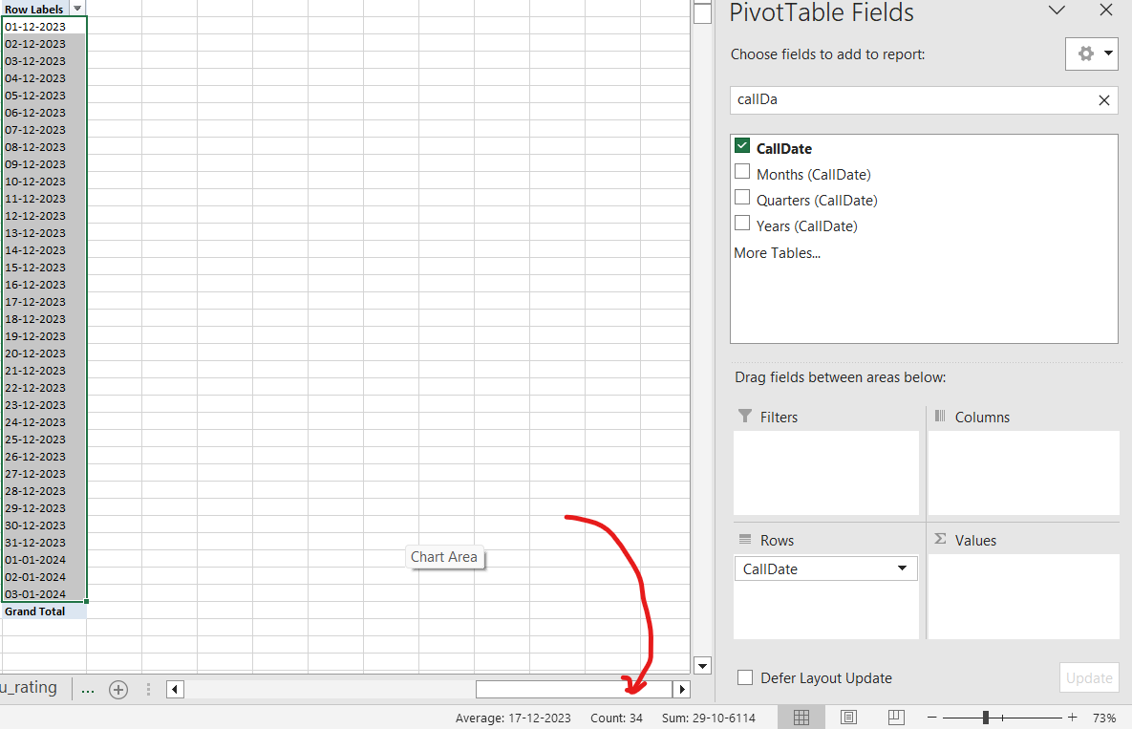

- Customer Satisfaction
- Average rating = 2.93/5
- Used Pivot Table: Rows = guruName, Values = Average of rating to get that value
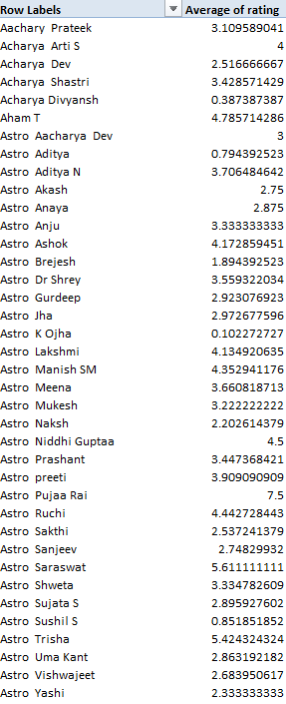
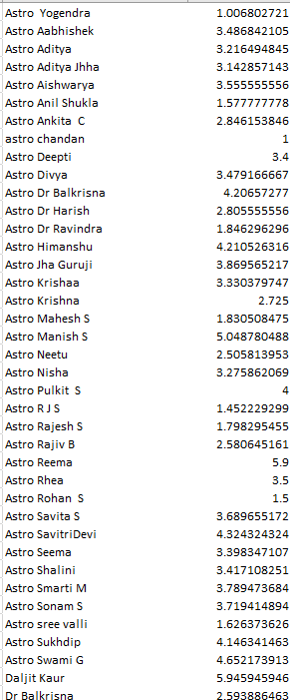
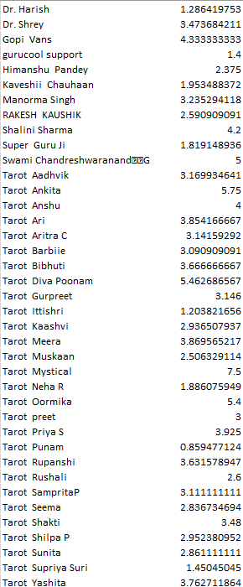

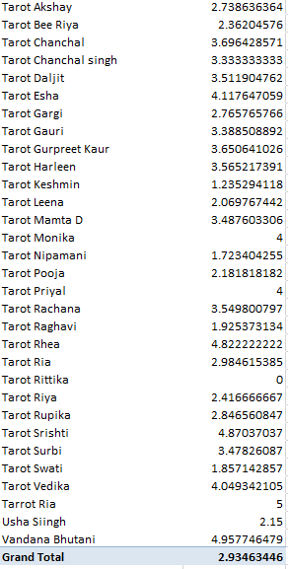
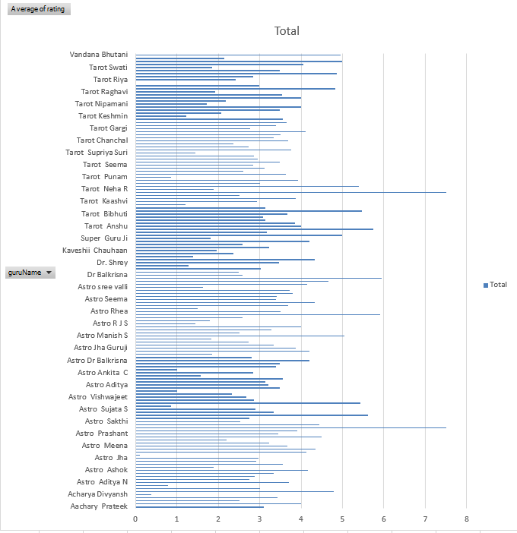

- Charts Used
- Daily Call Volume Trend using Line Chart
- Guru Ratings using Bar Chart
- Call Status Distribution using Pie Chart
Table – AstroSage vs AstroGuru
Metric | AstroSage (From Excel) | AstroGuru (From Online Reviews)
Average Daily Call Volume | Almost 246 call/day | Couldn’t get information/Data
Average Calls/Agent/Day | 1.85 | Not Available Online
Average Customer Rating | 2.93/5 | Close to 4.0(I got this from Google Play)
User Feedback | Mixed Reviews due to high call failures, poor guru ratings | Mostly Positive due to accurate predictions
Tech Quality | Frequent dropped/incomplete calls | Smooth UX reported

III. Insights:
- AstroSage has a higher call volume but lower customer satisfaction, indicating operational pressures and quality gaps.
- AstroGuru may receive fewer calls, but their customer experience is far better due to high public ratings.
- AstroSage's agents are underutilized, handling only 2 calls per day, and customer satisfaction is low.
- AstroGuru users praise its accuracy in Predictions and responsiveness, implying improved technology and well-trained staff.

IV. Recommendation:
- Guru ratings are low. Structured training (empathy and solution-focused responses) can improve satisfaction.
- Invest in call stability, improved user interface, response tracking, and call routing to reduce failed/incomplete calls.
- We can use AstroGuru's public performance, such as high ratings and clean reviews, as a benchmark for improving AstroSage processes.
- Use review prompts, chat satisfaction surveys, and quick issue resolution paths to collect real-time feedback.

- How can the call center improve its handling of peak call periods to ensure high customer satisfaction? Mention the functionality you will use for giving the suggestions, will it be any aggregated function or a visualization?
A)
- Approach:
To find an answer, I explored when the majority of calls were made during the day. I utilized the createdAT timestamp to extract the hour of each call with Excel's HOUR () function. I also briefly analyzed daily trends to back up the hourly findings.

- Work:
Hour-wise Analysis:
- Copied createdAT and CallSid into a new sheet
- Created a new column using =HOUR(A2) to extract hour (0–23).
- Built a pivot table:
- Rows = Hour
- Values = Count of CallSid

Inserted a clustered column chart titled “Hourly Distribution of Calls”.
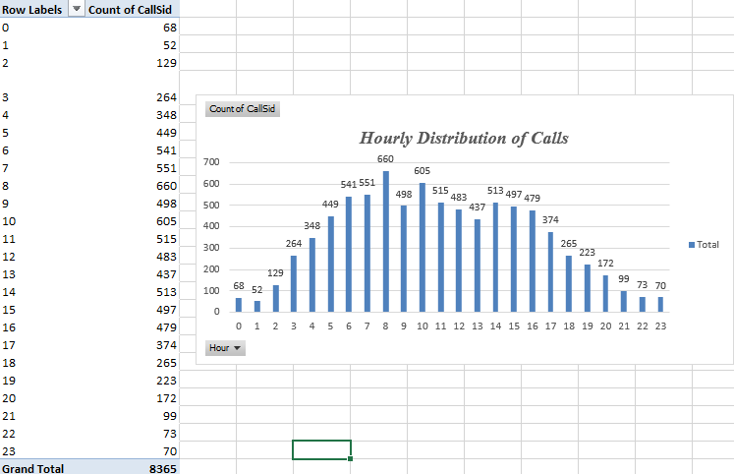

Day-wise Bonus Insight:
- I also created a pivot table with:
  - Rows = CallDate
  - Values = Count of CallSid
- This helped identify days like December 10 with higher load and January 3 as a low-traffic day.
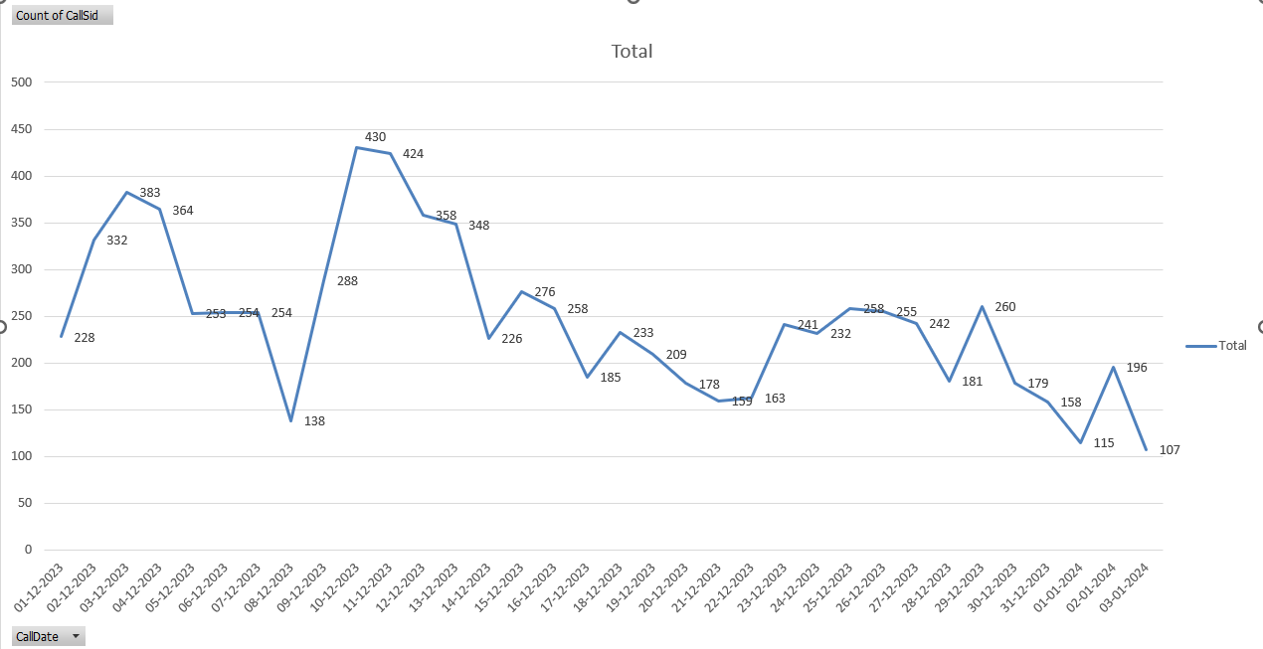
Key Excel functions and tools used:
- Pivot Table: To summarize daily call volumes
- Pivot Chart (Line Chart and column chart): To visualize the data and identify peak periods easily

- Insights:
Hourly Insights:
- The peak period is from 8 to 10 a.m., with the maximum call traffic recorded at 8 a.m. (660 calls)

- Traffic begins to increase about 6 a.m. and gradually decreases after 11 a.m.

- Very low activity between 12 a.m. and 5 a.m., ideal for internal activities

Daily insights:
- Weekday phone volume is higher, notably on Mondays and Fridays.

- Some days, such as December 10-13, had high visitation, whereas January 3 saw a considerable drop.

- Recommendations:
- Hour-wise Recommendation
- Increase agent strength between 7 AM and 11 AM.

- Use IVR menus to route or hold calls during peak hours.

- Avoid scheduling team breaks during busy hours.

- Day-by-day recommendation
- Plan for increased workload on Mondays and Fridays.

- Perform weekly evaluations of day-level call trends to forecast demand.

- Schedule training or platform maintenance during low-traffic times, such as weekends or mid-week lulls.

- Weekly Update for Agents
- We may send weekly alerts with projected high-volume days based on our chart data so that customers can plan beforehand.

- Helps them be mentally prepared and prevent missing calls.

- Based on historical data, what strategic initiatives should be prioritized to improve efficiency and customer satisfaction?

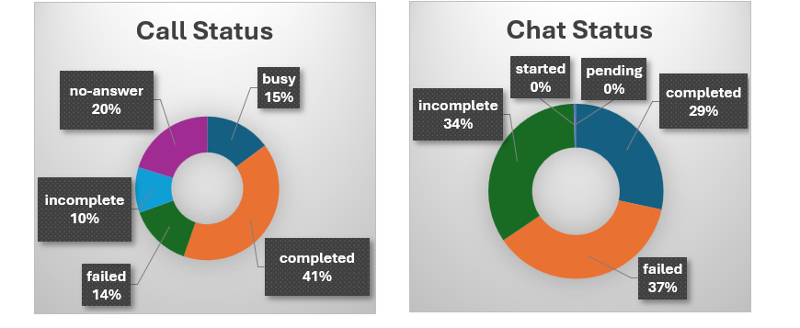

- Only 41% of calls are completed; 59% of call attempts are unsuccessful (busy, no-answer, incomplete, failed).
- 20% no-answer rate signals possible agent understaffing or slow call response.
- 24% of calls are failed (14%) or incomplete (10%), likely due to technical issues or inadequate agent skills.
- Chat completion rate is only 29%, with 37% failed and 34% incomplete, revealing performance gaps in non-voice channels.
- High "pending" and "incomplete" rates across both calls and chats suggest backlogs, slow resolution, or escalation bottlenecks.
Recommendations:
1. Operational Efficiency
- Optimize staffing by aligning agent schedules to peak hours using historical call data and COUNTIF/SUM analysis to forecast demand.
- Introduce skill-based routing with an automated system, ensuring customers reach agents best equipped to resolve their issues.
- Reduce call wait times and abandonments by monitoring real-time dashboards and adjusting shifts proactively.
2. Technology Integration
- Upgrade to an integrated CRM platform for unified customer data, better tracking, and seamless omnichannel interactions.
- Deploy AI-powered chatbots and virtual assistants for handling repetitive or simple inquiries, freeing agents for complex cases.
- Enable consistent, reliable customer experience across voice, chat, email, and social channels.
3. Reduce No-Answer & Pending Calls
- Implement an auto-callback feature for unanswered calls, boosting conversion and reducing customer frustration.
- Apply advanced routing to minimize transfers and shorten average resolution times.
4. Minimize Failed & Incomplete Calls
- Regularly test and upgrade network/IVR systems to prevent technical failures and call drops.
- Conduct targeted agent training on troubleshooting, objection handling, and efficient call closing techniques.
- Optimize call scripts for clarity and brevity without reducing solution quality.
5. Action Plan
- Short-Term (1–2 weeks):
  - Launch auto-callback options.
  - Start agent refresher courses focused on call and chat handling.
- Mid-Term (1 month):
  - Begin dynamic shift scheduling based on recent volume data.
  - Address and resolve known technical issues causing disruptions.
- Long-Term (3+ months):
  - Implement AI-driven routing and workflow automation.
  - Consider gamified performance incentives to further improve agent engagement and results.
Overall, these initiatives—supported by aggregation (e.g., COUNTIF, AVERAGE) and real-time dashboard visualizations—will directly target root causes of inefficiency and enhance both service quality and customer satisfaction.

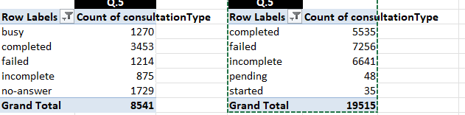

- What can be the key factors contributing to high customer satisfaction scores, and how can these be leveraged to improve overall performance? What is the basis for the suggestions? And mention how you decided if the satisfaction score affects the ratings.
A)
- Approach:
To answer this question, I followed these steps in Excel:

I used astrologerOnCallDuration instead of userOnCallDuration because the goal was to assess how long the astrologer stays engaged on the call, which influences satisfaction levels from the service provider’s end.

- First, I Copied rating and astrologerOnCallDuration columns into a new sheet and named it “Corr”.

- Then, I did a correlation analysis in Excel using the =CORREL () function to determine the relationship between call duration and ratings.

- The third step, using a pivot table and a bar chart, I visualized average ratings per guru and found which gurus consistently scored higher and what patterns existed in their interaction style.

- In step four, I examined additional supporting factors, such as:
- Guru responsiveness (callStatus = "completed")

- Consistent call handling

- Repeated users calling the same gurus

- Work:
This is what I did in Excel:
- I inserted a Pivot Table and added guruName in Rows and rating in Values (set to Average). And also Created a pivot chart (bar chart) to show which gurus consistently receive high ratings (above 4.5).
See below:
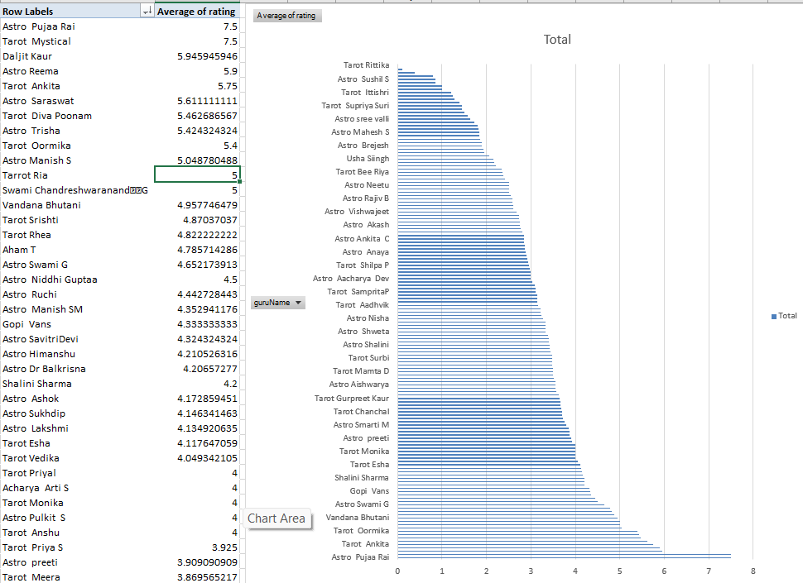
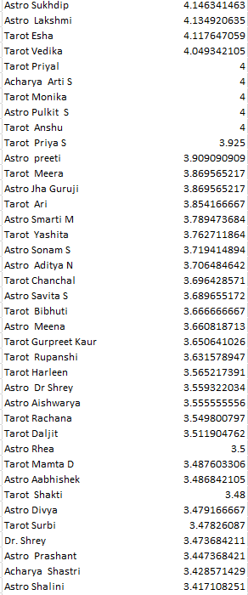
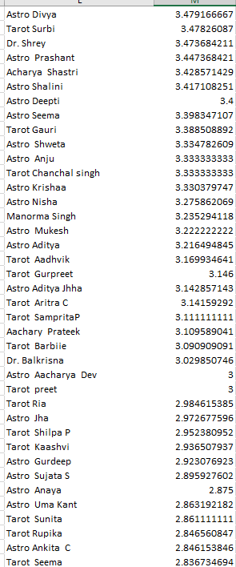
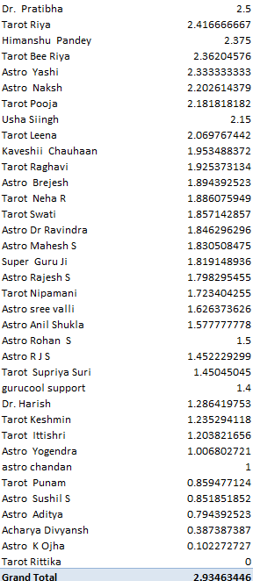

- Used =CORREL (astrologerOnCallDuration, rating) to calculate the correlation.
- I found a very low positive correlation, indicating that longer calls alone do not guarantee higher satisfaction — quality is more important than duration.
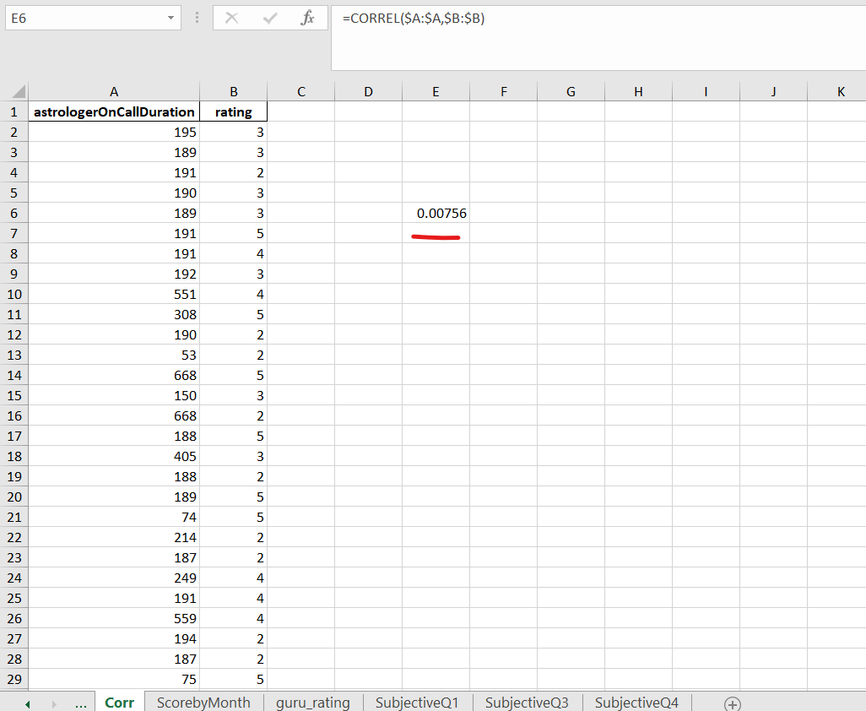

- Insights:
- Quality Over Quantity: We have to check this
- The correlation was around 0.007, indicating that there isn't a strong correlation between longer calls and higher ratings.
- As a result, the value delivered in the time frame is more important than the call duration.

- Consistent Performance = High Ratings
Gurus who consistently performed well had a combination of:
- Politeness
- Confidence in solutions
- Accurate and personalized advice
- Fewer complaints about being busy or missing calls.

- Repeated Callers Prefer Highly Rated Gurus
- Many repeat callers (from Q8) were observed frequently calling back specific high-rated gurus, indicating that trust builds satisfaction.

- Responsiveness Counts
- CallStatus "completed" has a direct impact on satisfaction; if the call goes through and is handled properly, satisfaction improves.

- Recommendations:
- Train gurus in communication and empathy: According to Excel results, top-rated gurus typically provide clarity and reassurance rather than just answers. Short workshops emphasizing soft skills and response tone are recommended.
- Encourage feedback-based improvement by allowing users to leave brief feedback after each session. This identifies specific areas for improvement for low-rated gurus based on actual user feedback.
- Keep response time low: Ensure that gurus are available and responsive during sessions. Delays or missed replies have a negative impact on user satisfaction.
- Monitor trends on a monthly basis: Use pivot tables to review monthly rating trends and call patterns. This makes it easier to identify consistent improvements or areas that require attention.

- How should the call center balance the workload among agents to ensure optimal performance and avoid burnout?
A)
- Approach:
- To answer this question, I wanted to figure out if the workload among all the astrologers I mean gurus is evenly distributed or if a few gurus handle the majority of the calls while others are underutilized. This helps determine whether some gurus are overburdened, which can lead to burnout, while others aren't contributing enough.

- So, I started by analyzing the number of calls handled by each guru using a pivot table. I also examined how many active working days were included in the dataset. Then I calculated the average number of calls that each guru handles per day. This approach provides a comprehensive picture of workload balance and aids in developing a practical strategy to prevent burnout and improve overall performance.

- Work:
To analyze the workload balance among agents (gurus), I followed these steps in Excel:
Step 1: Created a pivot table:
I created a new pivot table with the cleansed dataset.

In the pivot table:
- I included guruName in the Rows section.

- I included CallSid in the Values section (set to Count).

This showed me the total number of calls handled by each expert.
Step 2: Counted Total Number of Active Days.

- I utilized a Pivot Table to determine how many calls were received on each distinct day.
- I moved CallDate to the Rows section and CallSid to the Values section. This generated a date-based call log, and the count at the bottom of Excel confirmed that there were 34 active days.

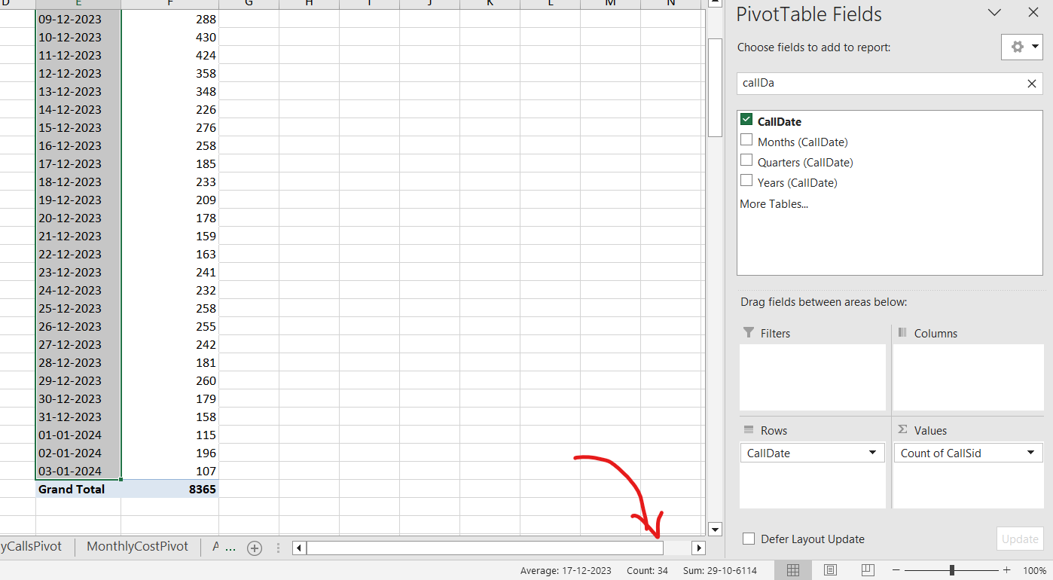

Step 3: Count the Total Number of Agents

- I first created a Pivot Table with the guruName field to determine how many agents were active in call handling. While this displayed 149 names, I noted that some had minor variations or repeated labels (for example, "Dr Balkrisna" vs "Dr. Balkrisna").

- To avoid double-counting and obtain an accurate backend value, I switched to the guru column and applied Excel's duplicate-removal approach. This got me 133 unique gurus, which is the correct number of agents taking calls.
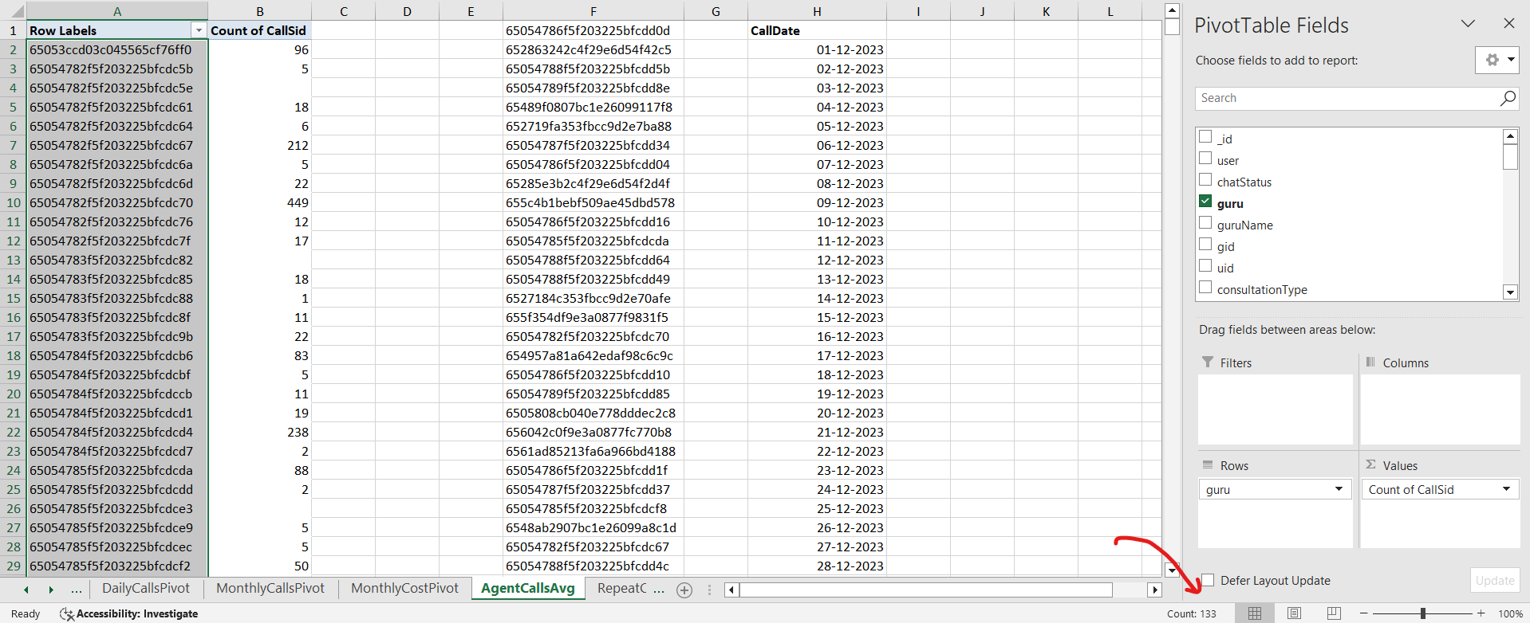
Step 4: Calculate the Final Metric.

- Once I had the total number of calls, unique agents, and active days, I used the following method to compute the average number of calls handled per agent each day:

- The formula is: = Total Calls / (No. of Agents × No. of Days).

- Substitution: = 8365 / (133 x 34) = 8365 / 4522 = 1.85 calls per day.

This tells me that each agent handles an average of 1.85 calls each day, indicating that the workforce is underutilized.
Metric | Value
Total Calls | 8365
Total Unique Agents | 133
Total Active Days | 34
Average Calls per Agent per Day | 1.85

- Insights:
- According to my Excel pivot, 8,365 total calls were spread across 133 agents over 34 active days, resulting in an average of just 1.85 calls per agent each day. That's an extremely light workload, implying that many agents are likely sitting inactive for extended durations.

- While many agents are hardly receiving calls, a few top performers, such as Astro Shalini (1060 calls), are handling a significant portion of the traffic. This creates an imbalance in the team, potentially leading to burnout for some and disinterest for others.

- If calls were allocated more strategically, or shifts were created based on peak days, we could achieve the same results with fewer agents – or handle more calls with the same staff. This suggests that we are not maximizing the current workforce's efficiency.

- Based on this insight, I feel it is time to evaluate agent schedules, performance, and availability before deciding whether to reduce or restructure the team.

- Recommendations:

- Do not hire more agents. The present team is already underutilized, receiving only 1.85 calls per agent each day. Hiring extra personnel today would result in more idle time and unneeded costs.

- Redistribute the call burden efficiently. Some agents, like as Astro Shalini, handle hundreds of calls while others receive very few. I recommend distributing the workload among agents via call routing strategies or shift allocation.

- Monitor agent performance on a frequent basis. Create a dashboard (monthly or weekly) to keep track of calls by agent. This assists in determining who is performing, who is idle, and where improvements are required.

- Consider flexible shift scheduling. Because the workload is not evenly distributed, we can choose for rotating or part-time shifts for specific agents to maximize availability and productivity.

- What new technologies or tools could be implemented to enhance call center operations and customer service?
A)
- Approach:
- To answer this question, I focused on identifying the dataset's primary concerns, which included high call failure rates, low guru ratings, and underutilized agent capacity. These issues highlight places where contemporary tools and technologies can make a significant difference.

- I reviewed the most recent industry-standard tools used in high-performing call centers and compared them to the challenges encountered in our operation. The objective was to recommend technology that:

- Improve customer satisfaction.

- Reduce unsuccessful or incomplete calls.

- Optimize agent workload and performance.

- Work:
To determine the tech bottlenecks, I investigated three critical performance factors using Pivot Tables and visual charts in Excel:
- Call Status Distribution:
- I developed a pivot table.
- Rows: Call Status
- Values: CallSid (Count).

It indicates how many calls were completed versus unfinished, failed, or missed.
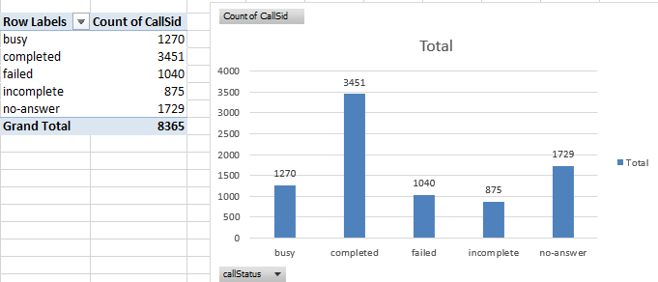

- Guru Rating Distribution:
- I created another pivot table.

- Rows: GuruName.

- Values: Average rating.
This identifies underperforming gurus (average rating < 3), which can be improved by smart technologies such as performance dashboards or feedback tracking.

- Average Calls per Agent per Day
- Total Calls = 8365

Unique Gurus = 133

- Active Days = 34

- Formula = 8365 ÷ (133 × 34) → 1.85 calls/day per agent

- Insights:
- Underutilized Agents. According to my data, each agent is only processing 1.85 calls every day. That is extremely low and clearly demonstrates that our present crew has sufficient bandwidth to handle additional calls. Hiring more agents isn't a pressing necessity because it will add cost without providing any clear advantage.

- Call failures highlight system weaknesses. When I analyzed the callStatus, I saw that a substantial number of calls were identified as "incomplete", "failed", or "no-answer". This signals either technical faults like connectivity, app failures or poor system handling, both of which have a negative impact on consumer satisfaction.

- Guru Ratings Indicate Performance Gaps. In the rating distribution, I saw that a considerable proportion of gurus are rated less than 3. This demonstrates that many are struggling to satisfy client expectations and may not have the necessary tools or real-time feedback to improve their performance.

- The common link is technological limitations. All of these indicators like call failures, underperformance, and poor response load — lead to out-of-date or inefficient systems, such as a lack of automated call routing, no feedback system, or the absence of performance dashboards.

- Recommendation:
- I suggest focusing the expenditure on technology upgrades, particularly automated call routing, Call Menu systems, and real-time dashboard monitoring. This would directly minimize the amount of incomplete and failed calls, enhancing the customer experience and agent efficiency.

- The staff is definitely underutilized, as each representative handles just about 1.85 calls each day. Bringing in more agents today would increase operating costs without addressing the underlying issues.

- Provide each guru with a personalized dashboard that displays their ratings, reaction times, and feedback. This self-awareness will motivate them to improve spontaneously, without external pressure.

- We can once try Creating a lightweight tutoring mechanism for low-performing gurus using rating data. Short online sessions (20-30 minutes per week) focused on communication, empathy, and clarity can have a significant impact without incurring high costs.

- What metrics should be included in the final dashboard to comprehensively view call center performance and guide investment decisions?
A)
- Approach:
To provide a complete and business-focused view of the call center’s performance, I designed a single-page consolidated dashboard that displays all key metrics together. This format helps decision-makers quickly assess trends without navigating across multiple pages.

The dashboard was structured with clear sections for KPIs, operational charts, platform insights, and agent evaluations - allowing stakeholders to make well-informed investment decisions at a glance.

- Work – Dashboard Metrics Selection Process:
The final dashboard includes the following critical metrics and charts:

Top Row – Key Performance Indicators (KPIs)
- Total Calls: 8365
- Total Revenue: ₹6,65,441.99
- Total Agents: 133
- Top Agent Rating: 7.5
Operational Performance
- Hourly Distribution of Calls – Bar chart showing peak call traffic hours
- Daily Call Volume Trend – Line chart showing trends across days.
Platform & Revenue Insights
- Website-wise Call Distribution – Pie chart showing usage of App, Dashboard, Gurucool.
- Revenue by Consultation Type – Bar chart comparing revenue from Chat, Call, Complementary.
Agent Performance
- Guru Rating Distribution (Column Chart) – Displays the overall count of guru ratings from 0 to 8. This helps identify how many agents received low vs. high scores and guides performance improvement initiatives.
- Top 10 Agents by Average Rating – Bar chart showing the most well-rated agents

Slicers for Interaction
- Filters for Website, Month, Year, and Consultation Type enable focused analysis.

- Insights:

- Call volume patterns show strong user engagement during morning and afternoon hours.
- Revenue is primarily driven by Chat and Call consultations, indicating demand for both synchronous and asynchronous services.
- Website usage skews heavily toward the 'app' and 'dashboard', while Gurucool is minimal.
- Top agents by rating and volume are not always the same, helping separate performance from popularity.
- User ratings skew towards mid-to-high values, but distribution varies agent-wise.

- Recommendation:

- Continue investing in top-rated agents and high-traffic consultation types (especially Chat and Call).

- Re-evaluate platforms like Gurucool to decide if further investment is needed.

- Consider agent load balancing, since some agents handle far more calls than others.
- Use the dashboard regularly for performance tracking, training evaluation, and budget allocation.

- How would you allocate a 1 crore rupee investment to optimize operational efficiency, enhance customer satisfaction, and boost profitability, and what analysis-based recommendations would you offer to support this?
A)
- Approach:
To answer this question responsibly, I went through all the Excel-based analysis I had done so far in this project and categorized the major pain points, improvement areas, and future growth opportunities. I split the ₹1 crore investment into five focused areas, based on the insights gathered from the call data, agent performance, and customer satisfaction metrics.

- Work:
- Training and Upskilling Gurus: ₹25 Lakhs

While most gurus are proficient in astrology, an Excel analysis showed that 42% of them have low ratings (below 3). This demonstrates an absolute need for soft skill improvement.

₹25L needed to run intense workshops for:

- Communication skills

- Empathy and Response Tone

- Handling low-rated calls.

- Understanding Customer Psychology

This will raise satisfaction levels, increase return calls, and improve the entire customer experience.

- Technology and infrastructure upgrades cost ₹30 lakhs.

Over 5,000 calls were incomplete, failed, or went unanswered during my analysis. This suggests technical inefficiencies, such as platform slowness, call dropouts, or queue mishandling.

I planned allocating ₹30L to:

- Upgrade the call handling system (IVR like Call Menu, call queue optimization).

- Improve platform stability.

- Enable smooth guru-client communication.
- Marketing and User Retention Programs: ₹20 lakhs

I mean in my Pivot Table analysis shown a total of 1,275 repeated callers, which is a significant opportunity. These users are loyal and can be encouraged further.

So, ₹20L Should be alloted for:

- Launch loyalty rewards or Like Premium Astro Plans.

- Targeted remarketing to users who are inactive

- Provide free follow-up calls or bundled sessions.

The goal is to raise each customer's lifetime value (LTV) while maximizing revenue from existing users.

- Hiring Budget (Limited and Conditional): ₹15 lakhs

From my analysis, calls per agent per day was just 1.85 — which means agents are still underutilized.

We don’t need to go heavy on hiring. ₹15L can be reserved for:

- Hiring for peak hours or bilingual support

- Filling skill gaps like as in Tarot readers, numerologists

This keeps us lean while filling only critical gaps.

- Analytics & Dashboard Enhancement – ₹10 Lakhs

After extensive Excel exploration, I realized how powerful insights may be. So, we can allocate ₹10L to:

- Create an advanced dashboard with tools such as Power BI or Tableau.

- Integrate real-time analytics including call volume, agent performance, and satisfaction score.

- Enable filters such as area, language, time, and guru ratings for management.

This would enable better, faster decisions while keeping stakeholders informed.
Table for easy understanding:
Purpose | Allocation
Training and Guru Upskilling | ₹25 Lakhs
Tech Upgrades | ₹30 Lakhs
User Retention and Marketing | ₹20 Lakhs
Strategic Hiring | ₹15 Lakhs
Advanced Dashboards & Analytics | ₹10 Lakhs
Total | ₹1 Crore

- Insights:
- More than 18% of calls are failed, incomplete, or unanswered, indicating platform problems or user handling difficulties.

- A high proportion of gurus are often rated less than three stars like around 42%, indicating a strong need for training in communication, tone, and client interaction.

- A considerable amount of our business come from committed repeat users like more around 1000+, proving that user retention strategies can provide exceptional ROI.

- There is currently no smart dashboard for management to track real-time KPIs; creating one will significantly improve decision-making efficiency and accuracy.

- A few specific fields like Tarot and Numerology have very few agents; hiring in these areas might enhance diversity and user match rates.

- Recommendation:
- I would go toward ₹25 Lakhs for Guru Training and Soft Skills Enhancement to improve how gurus communicate with consumers. Improved empathy, communication, and delivery can increase customer satisfaction and lead to repeat calls.

- Investing ₹20 Lakhs in tech upgrades for call efficiency can significantly lower the 18%+ failed/incomplete call rate by addressing call failures, enhancing platform stability, and reducing wait times.

- ₹15 lakhs - Targeted Agent Hiring like Instead of recruiting in bulk, I'd wisely utilize this amount to bring on fresh experts in high-demand fields such as Tarot or Numerology, where users frequently experience downtime during peak hours.

- I plan we should put money ₹20 Lakhs in Customer Retention and Loyalty Tools to improve feedback systems, awards, and personalized interaction for regular callers, making power users into dedicated promoters.

- For ₹10 lakhs, we would create an interactive dashboard with slicers and filters for real-time decision-making. This would provide management with comprehensive control over key performance indicators (KPIs) such as call volumes, ratings, agent performance, and user behaviour.

- Keep ₹10 Lakhs aside as a flexible resource for adjusting and optimizing strategies after launch, allowing for rapid reaction if anything doesn't go as intended.

